Lab Exercise 19
Setting up Snyk for SAST in Jenkins

Objective: To demonstrate the setup of the Snyk plugin in Jenkins for Static Application Security Testing (SAST), to automatically detect vulnerabilities in their codebase during development, thereby enhancing application security before deployment

Tools required: Snyk

Prerequisites: None

Steps to be followed:
- Configure Snyk as a SAST scan tool
- Create and configure a Jenkins job for Snyk integration
- Manage Snyk API and Jenkins credentials
- Configure the Jenkins job for scanning

Step 1: Configure Snyk as a SAST scan tool

- Visit https://snyk.io/, sign up for a new Snyk account, and log in

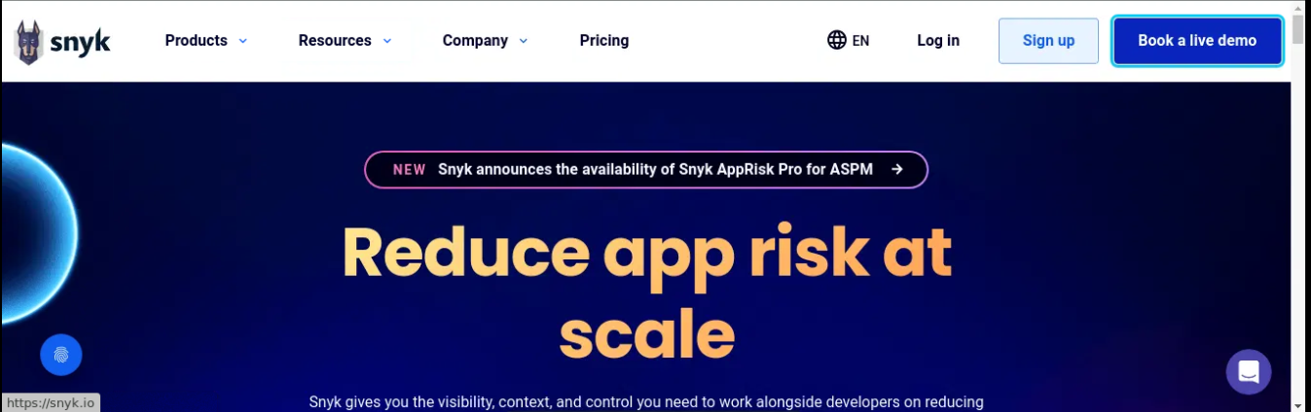

Output:-
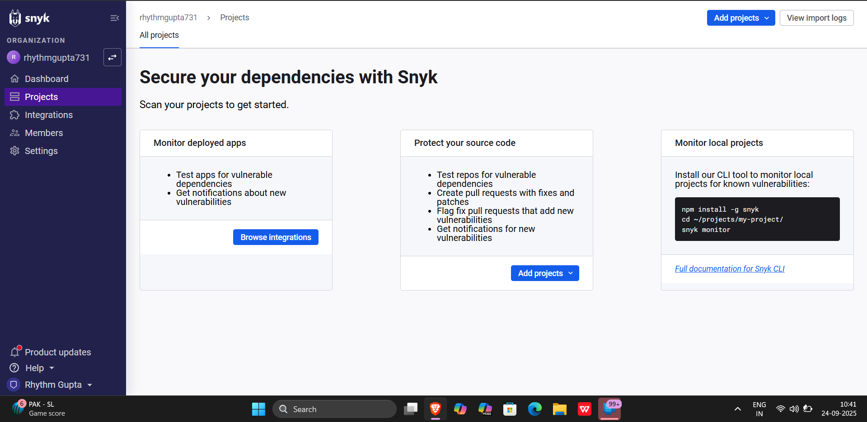

- Navigate to Integrations and select Jenkins

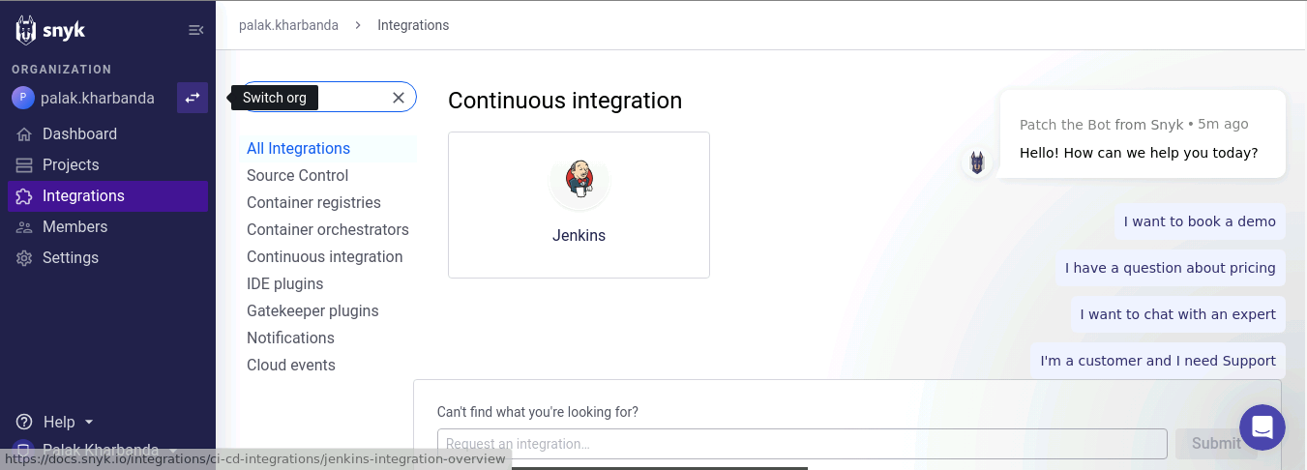

This will direct you to the documentation for integrating Snyk with Jenkins.

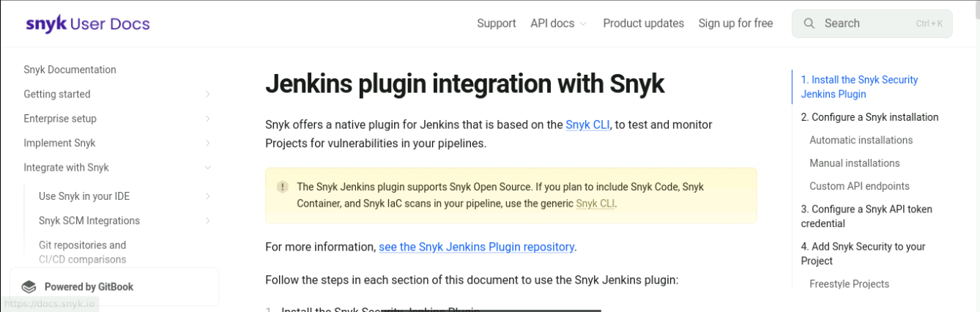

Output:-
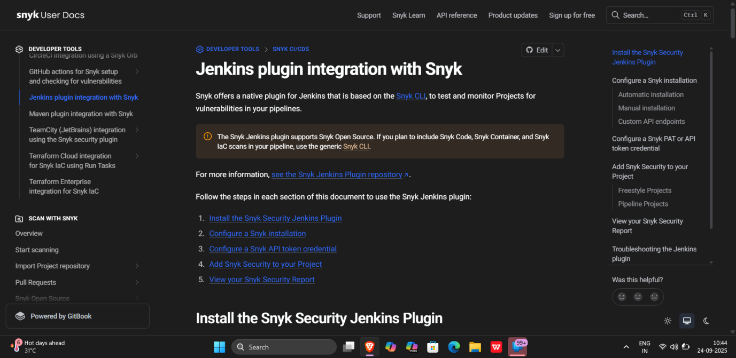

Step 2: Create and configure a Jenkins job for Snyk integration

- Open Jenkins and log in to the Jenkins account:

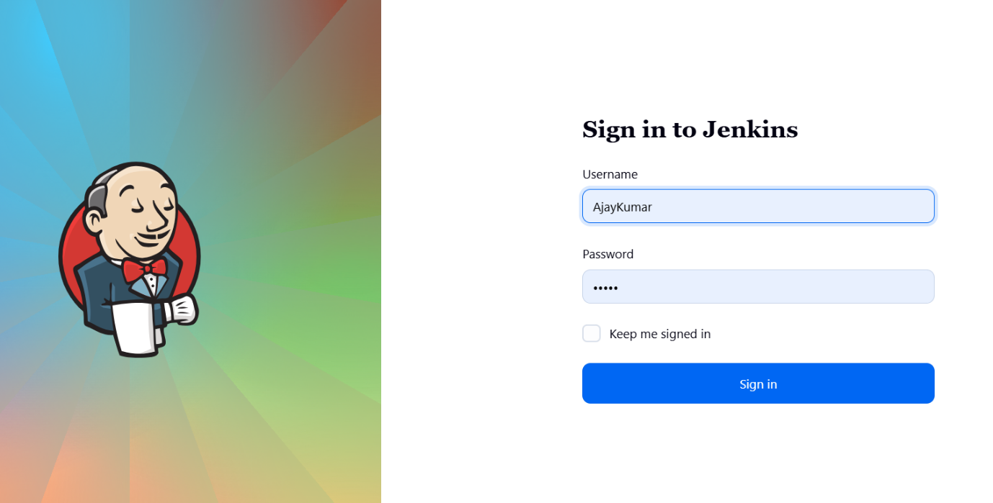

- To install the Snyk plugin, navigate to Manage Jenkins and click Available Plugins, search for Snyk Security plugin, and then click Install

Note: The credentials for accessing Jenkins in the lab are Username: admin and Password: admin.
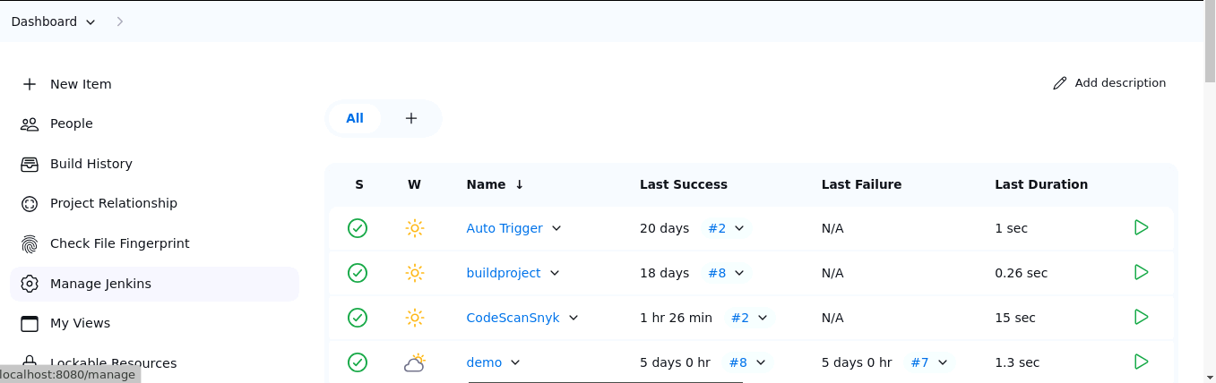

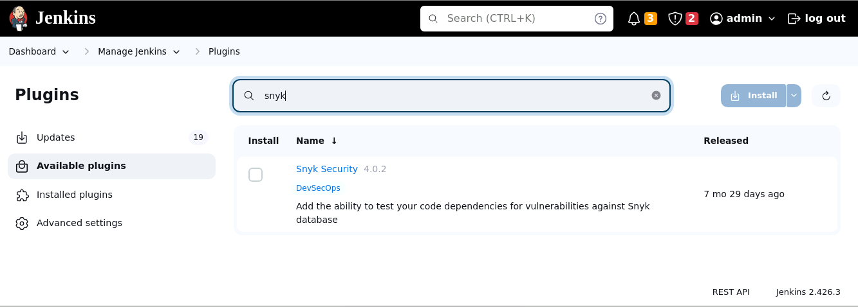

Output:-
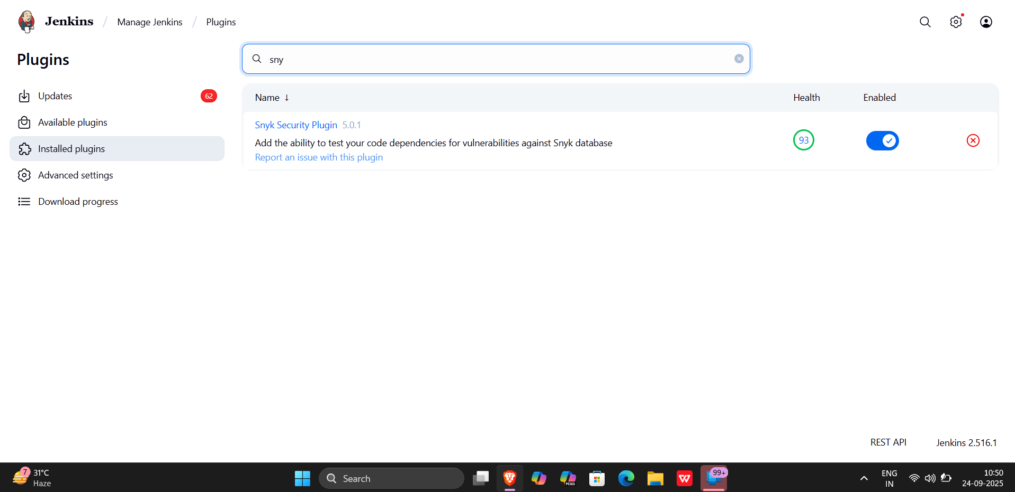

- To configure Maven and Snyk in the Global Tool Configuration, click on Tools inside Manage Jenkins

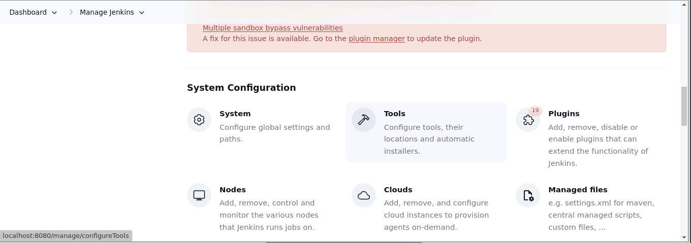
- To add Maven, click on Add Maven under Maven installations and enter Maven as the Name
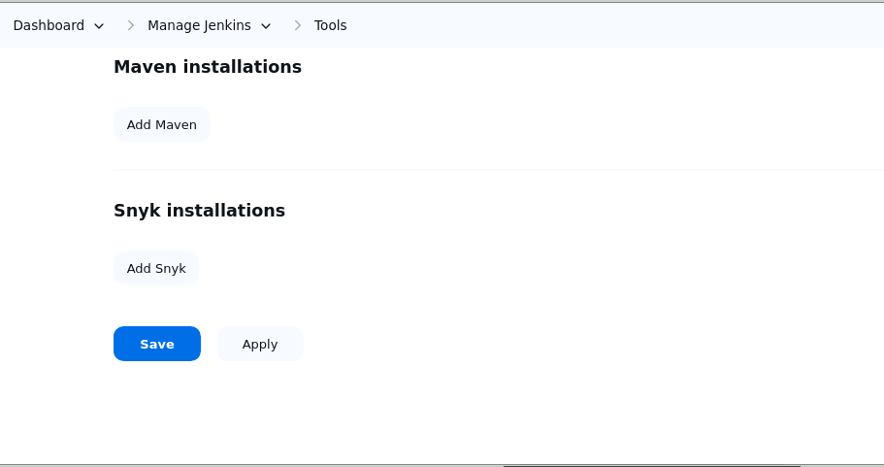
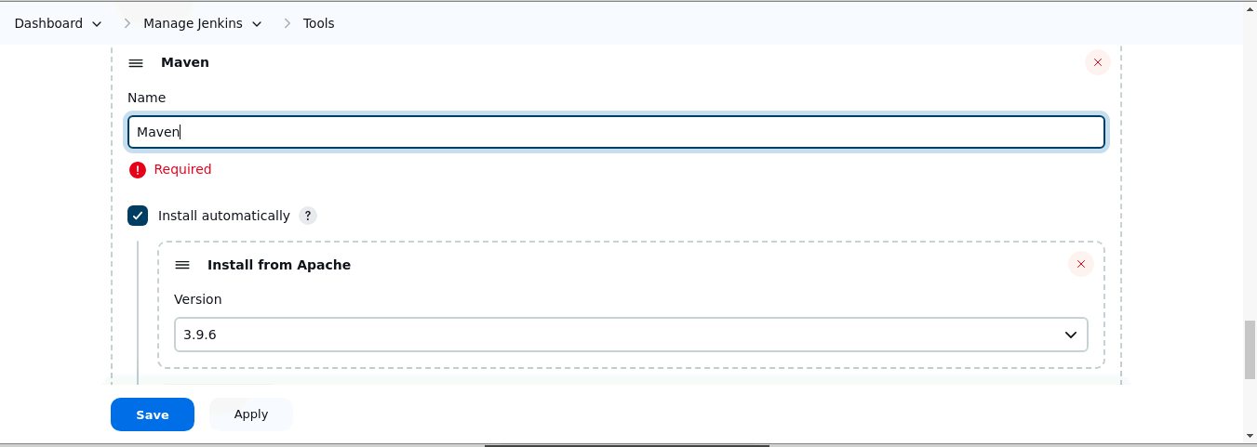

Output:-
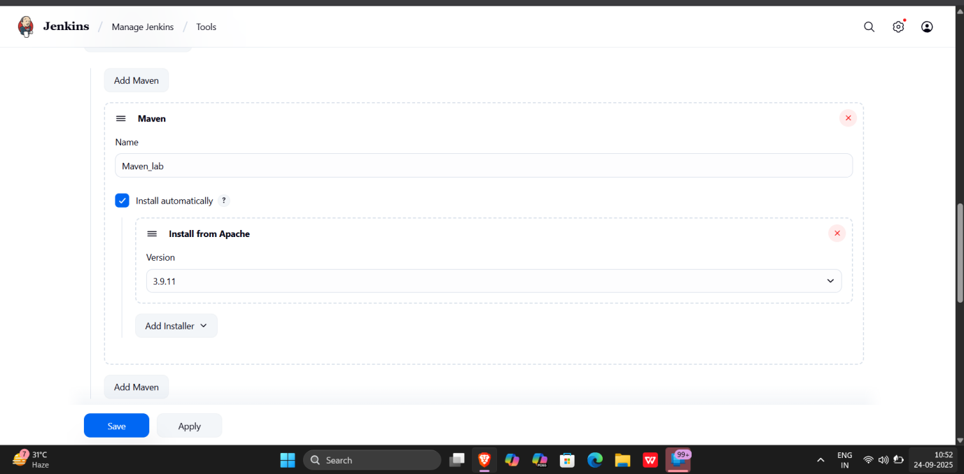

- To add Snyk, click on Add Snyk under Snyk Installations, add Name as Synk, and click on the Save button

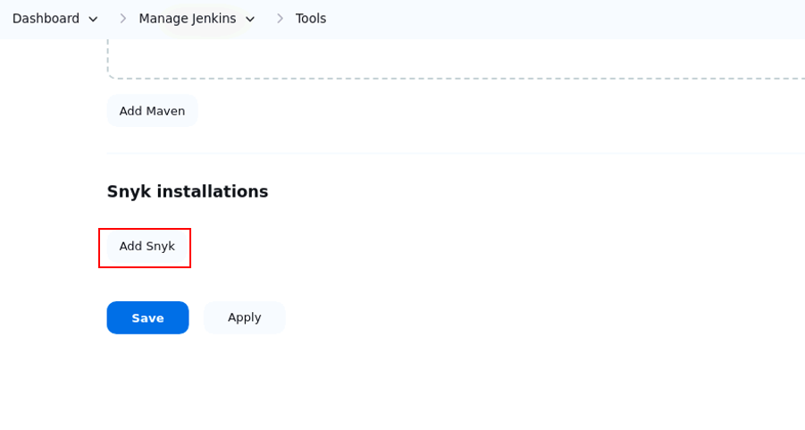

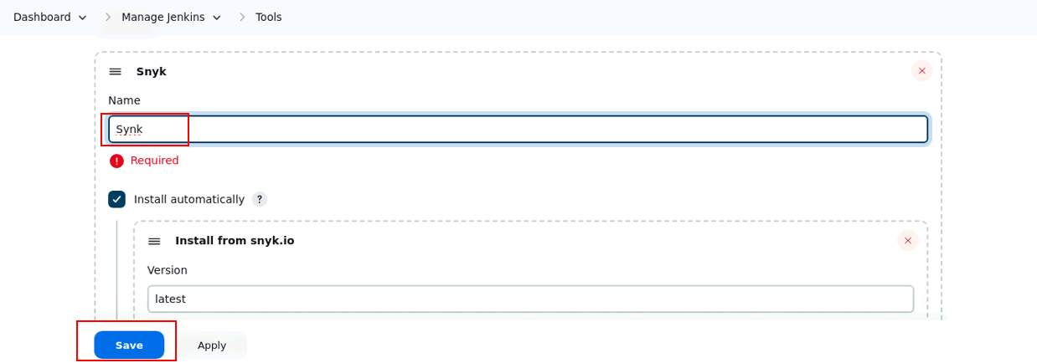

Output:-

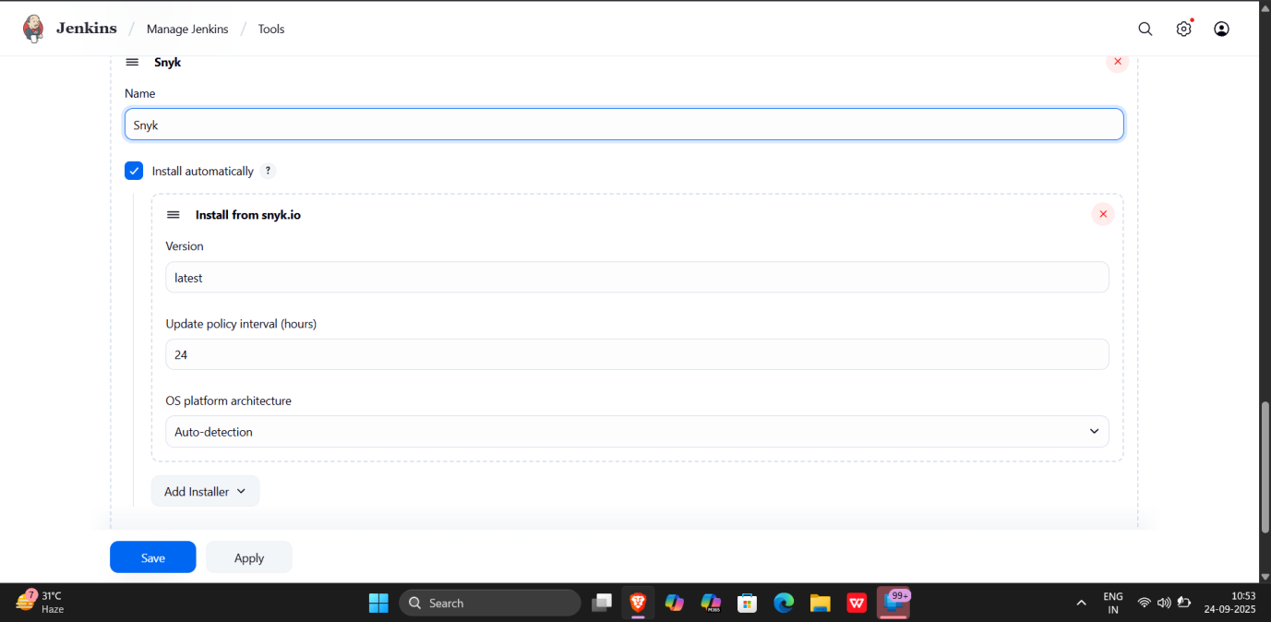

Step 3: Manage Snyk API and Jenkins credentials

- To retrieve your Snyk API token, go to Account Settings in your Snyk account, click on Click to show under the Auth Token key field, and copy the token for further reference

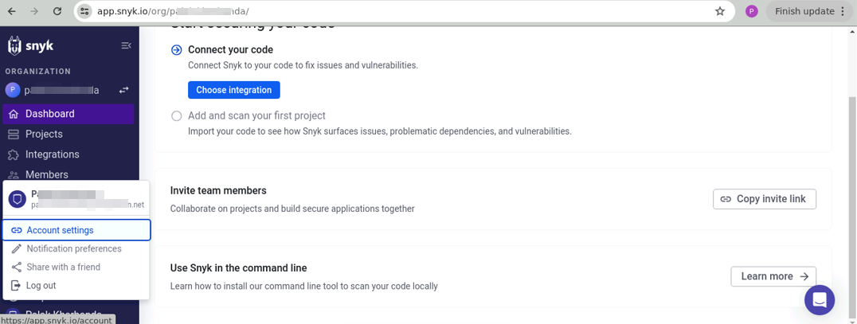

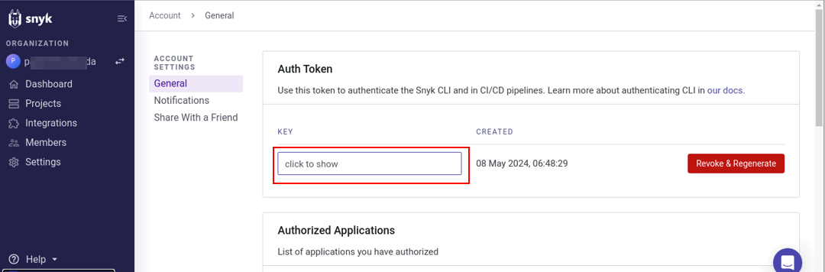

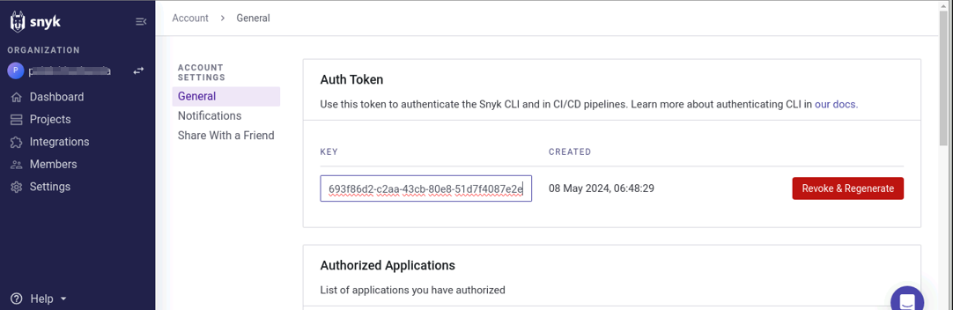

Output:-
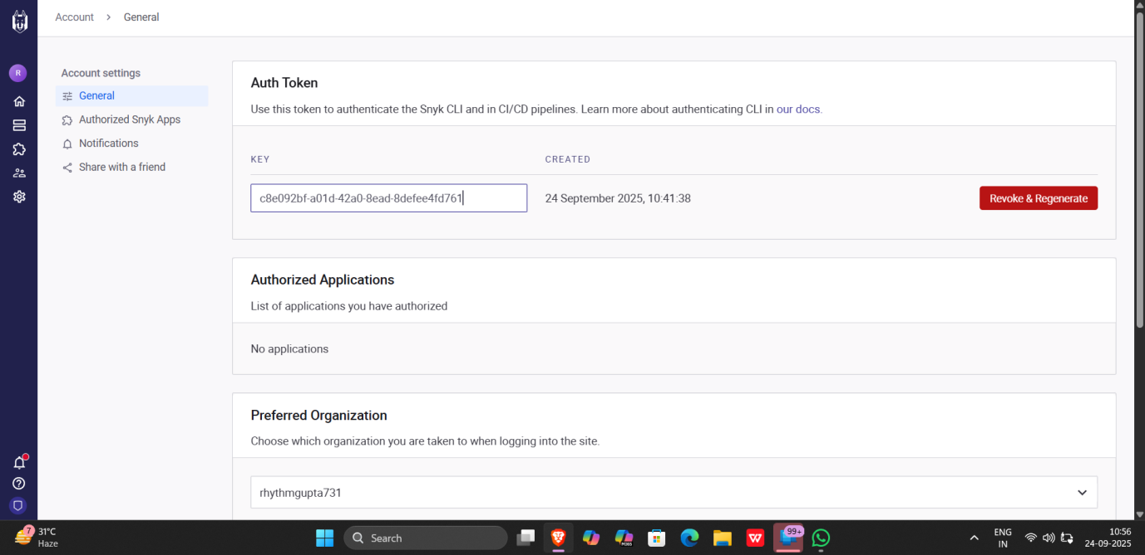

- In the Jenkins interface, go to Manage Jenkins, select Security, then choose Credentials and select global to add global credentials



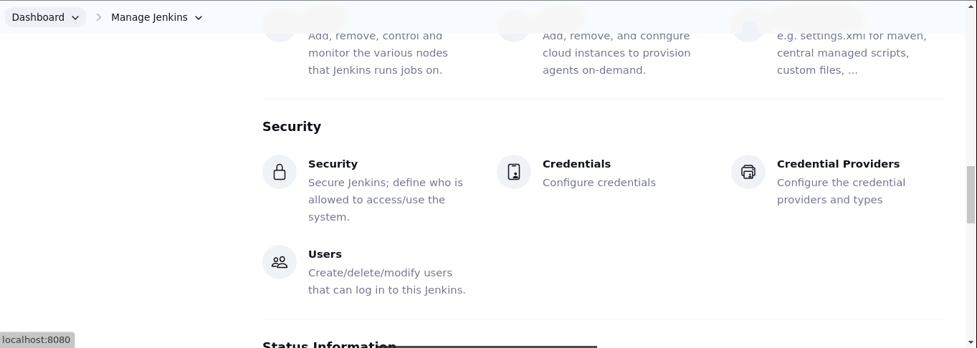

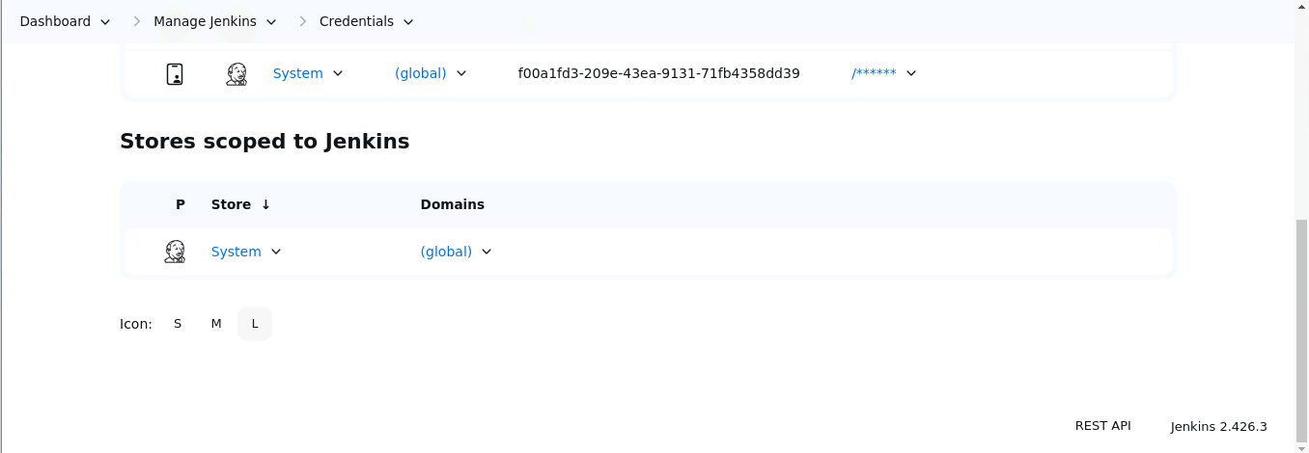
- Click on Add Credentials, select the Snyk API token from the Kind field, paste the copied token from step 3.1 into the Token field, and then click the Create button

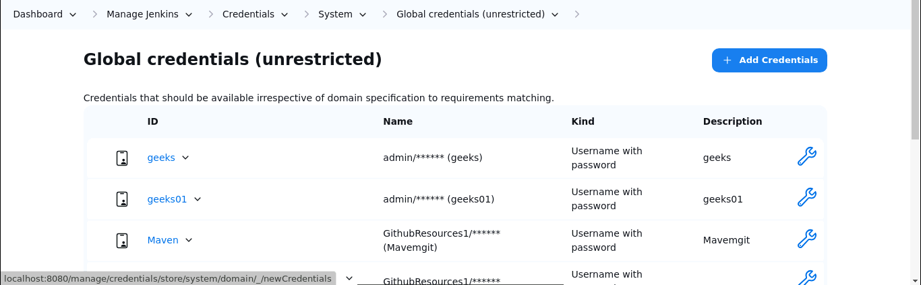

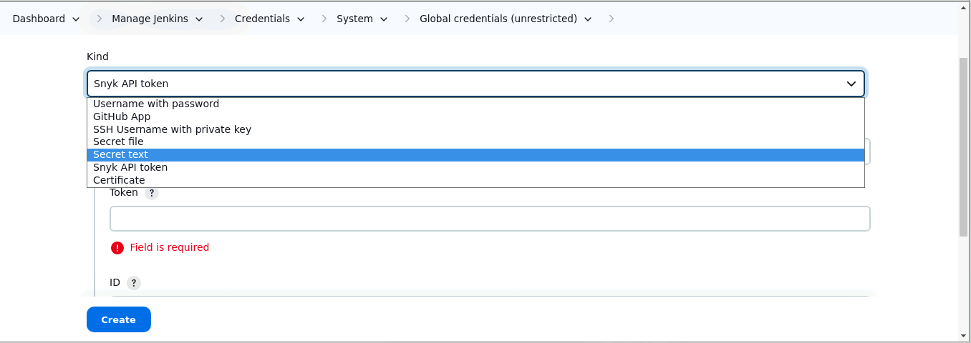

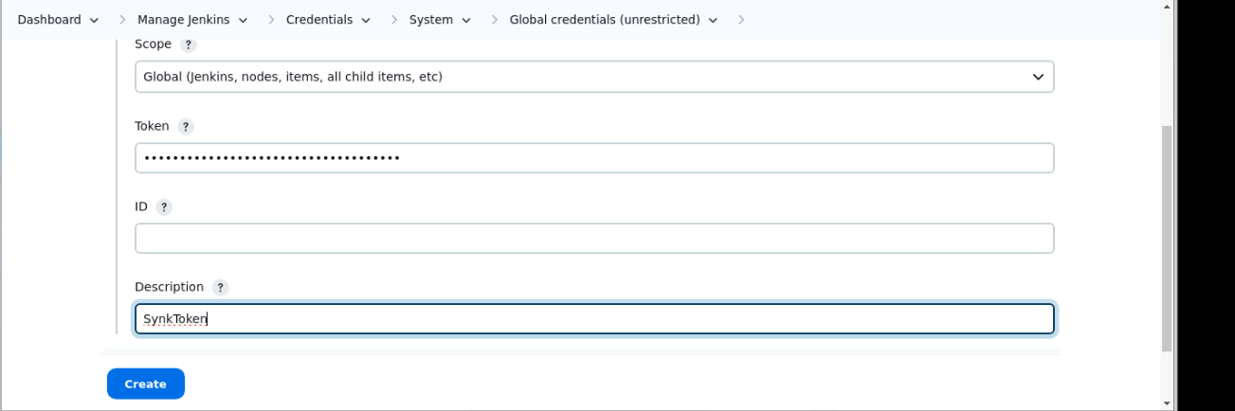

Output:-

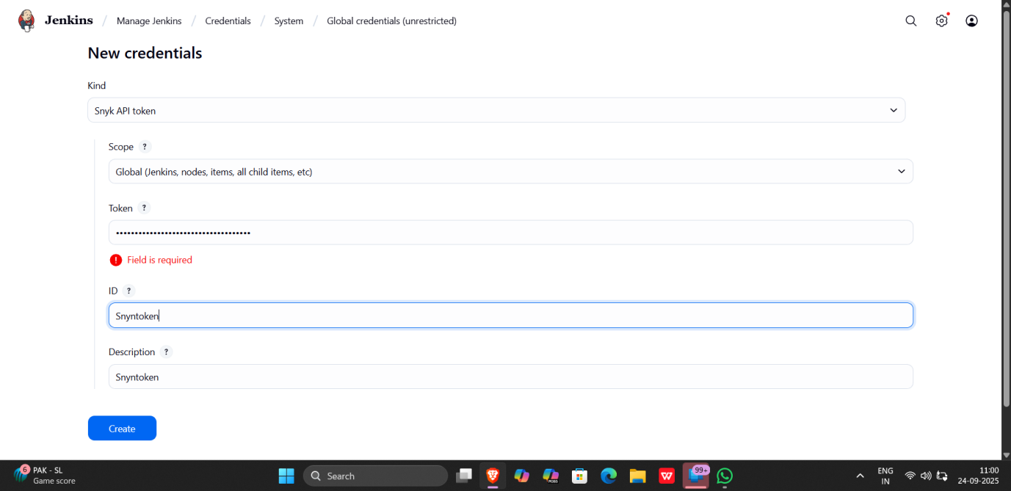

Step 4: Configure the Jenkins job for scanning

- To create a new Jenkins job, click on New Item, enter the item name as CodeScanSnyk, select Freestyle project, and then click OK

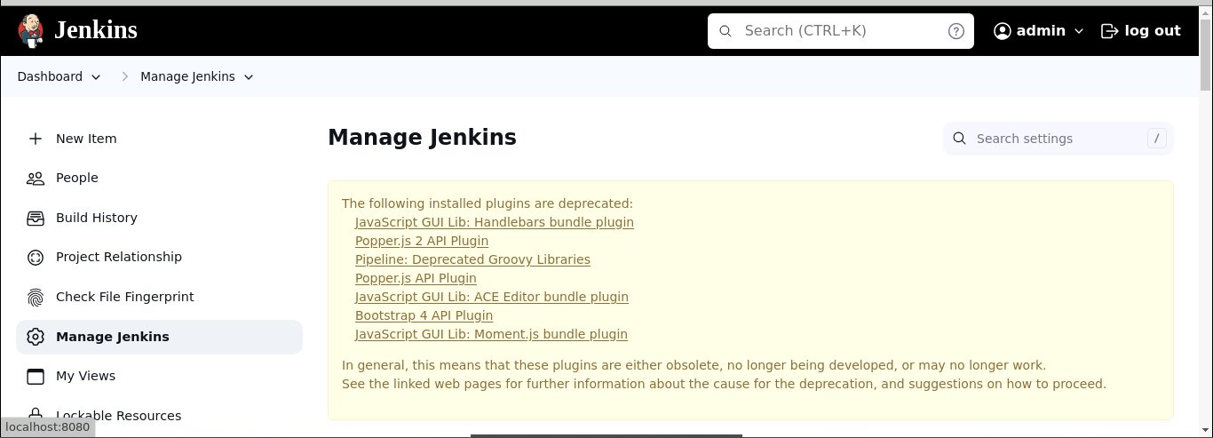
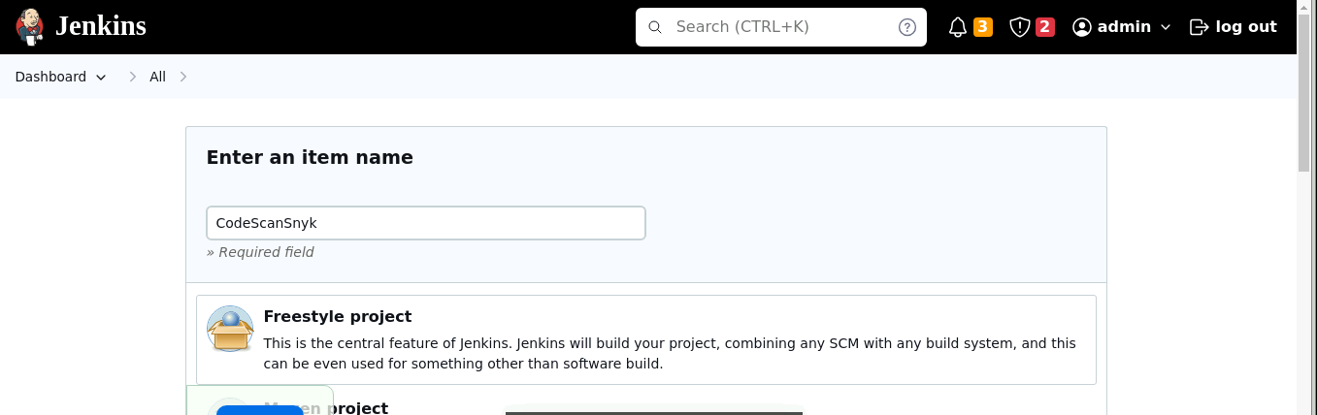
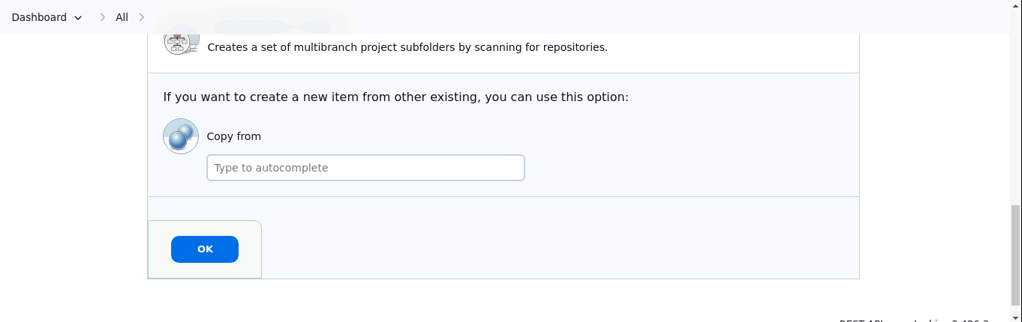

- After creating a job, go to Source Code Management and enter the GitHub repository URL. Then, under Build Steps, add the build step Invoke Snyk Security task with the name SnykToken. Finally, click the Save button to create the build.

Use GitHub Repo: https://github.com/hkshitesh/Secure-Coding.git

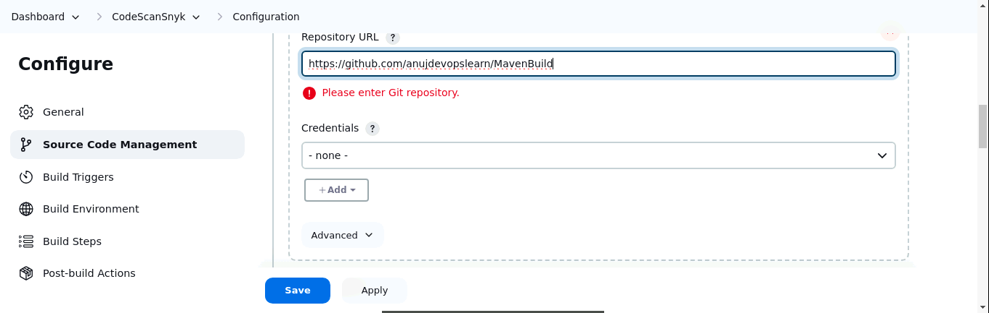

Output:-
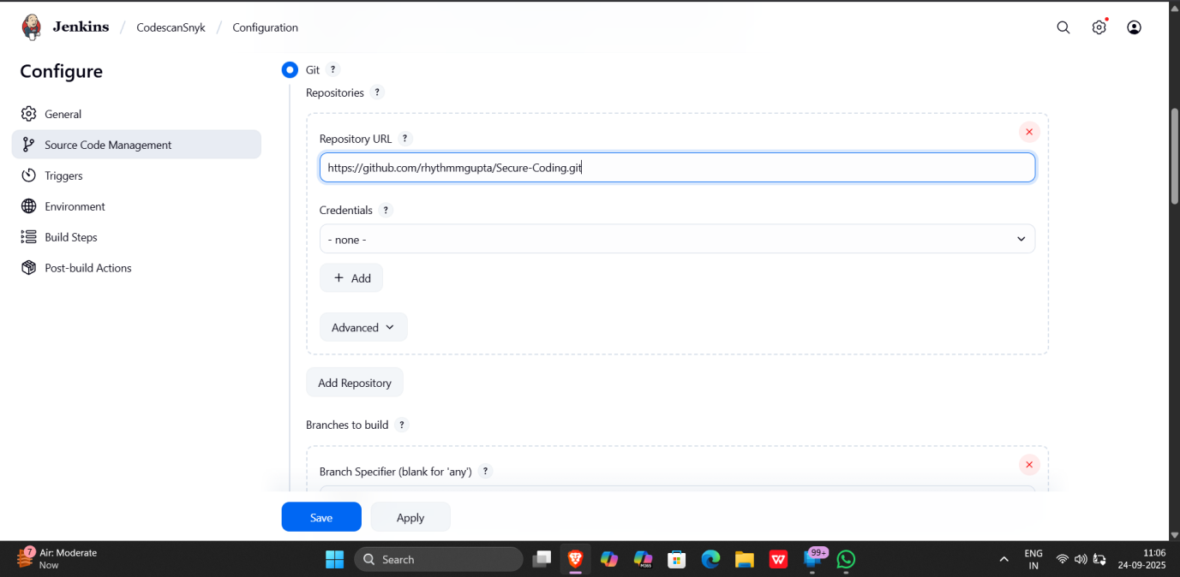

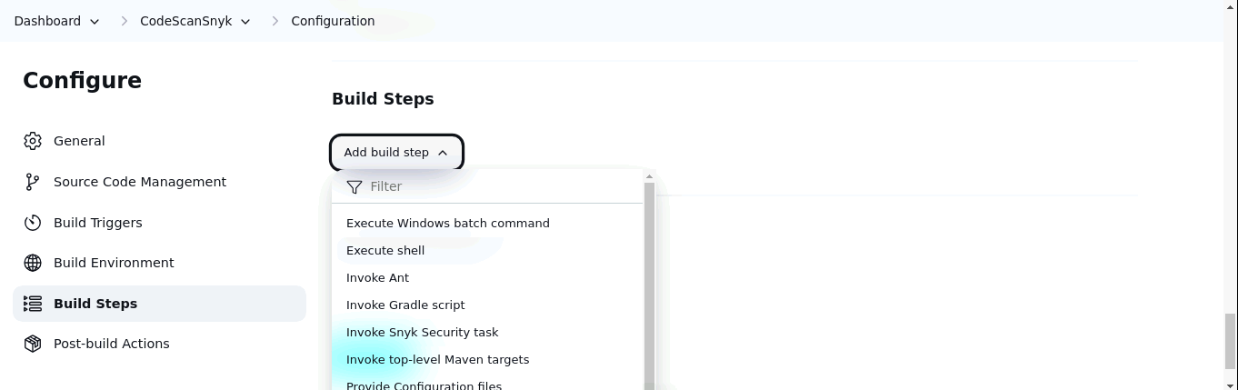

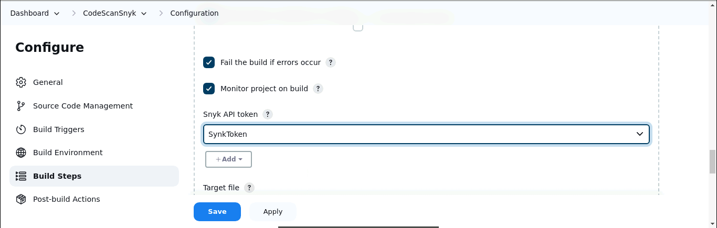
Note: For GitHub repository URL, use https://github.com/hkshitesh/Secure-Coding.git

Output:-

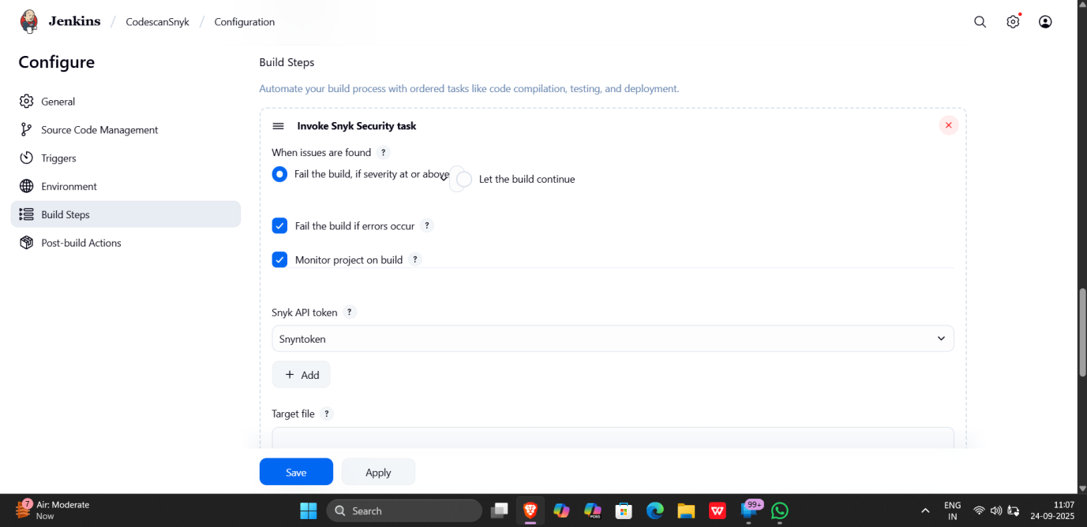

- To check the build status, click on the build link under Permalinks. After that, click on Console Output

Output:-
Build Failed! Vulnerabilities found . Snyk Plugin is working successfully

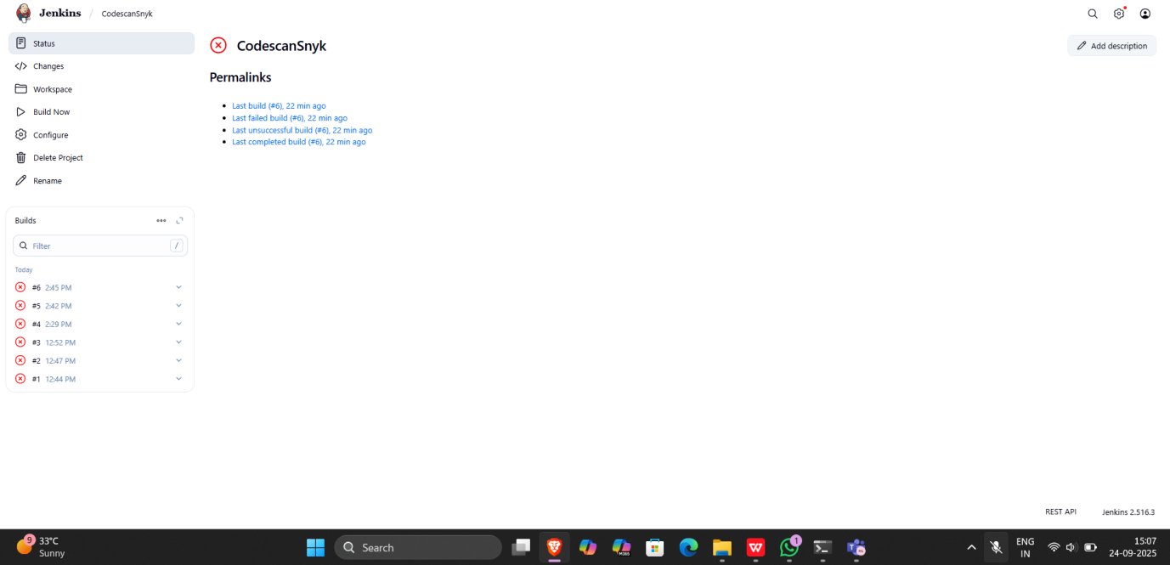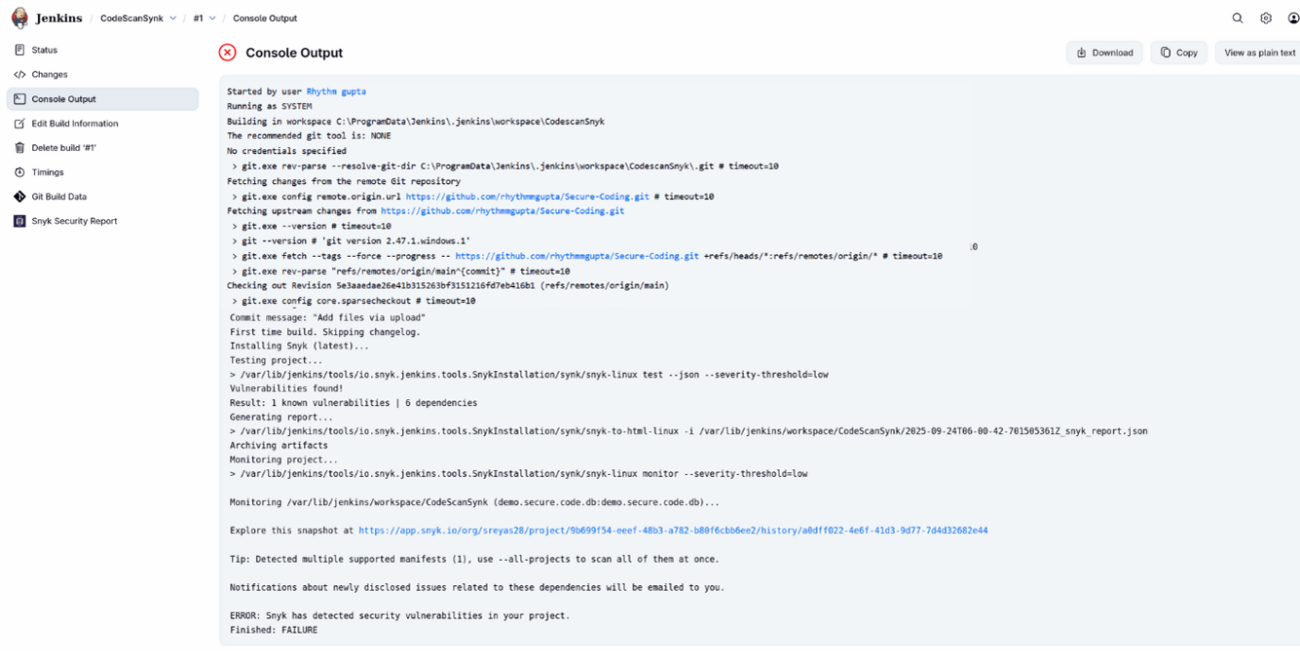

- To navigate to the Snyk tool to review code, scan reports under the Projects section

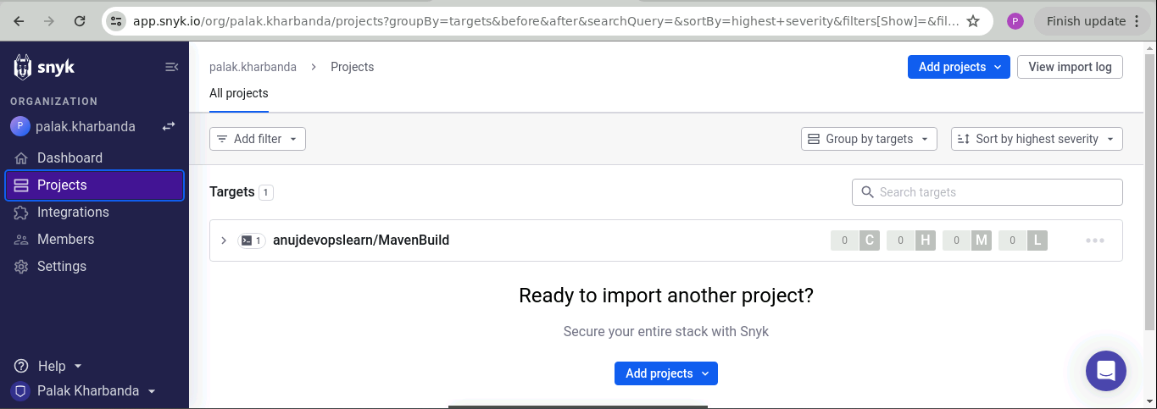

By following the above steps, you have successfully demonstrated the setup of the Snyk plugin in Jenkins for static application security testing (SAST), to automatically detect vulnerabilities in their codebase during development, thereby enhancing application security before deployment.

Output: -
